**KWAME NKRUMAH UNIVERSITY OF SCIENCE AND TECHNOLOGY**

COLLEGE OF ENGINEERING

CHEMICAL ENGINEERING DEPARTMENT

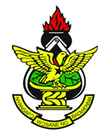

PRESENT THIS CERTIFICATE TO

**ISHMAEL KUMORDJI OKINE**

For successful completion of the curriculum in

BSC CHEMICAL ENGINEEERING

On this 14th day of April, 2019.

…………………………………………… …………………………………………………

Dean, College of Engineering Chair, Chemical Engineering Department

